**Information for Parents to Help Their Children Deal With Anxiety During the Covid-19 Pandemic**

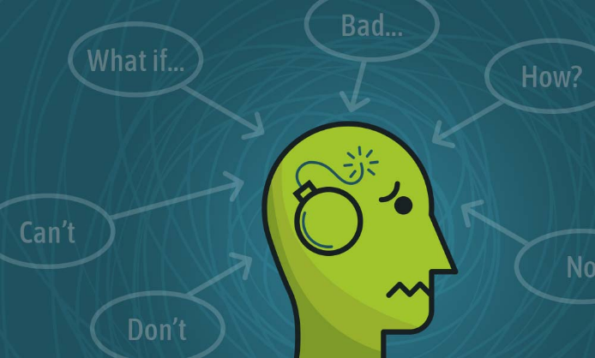In this time with all this uncertainty and typical life being disrupted we are all feeling anxious including children. Our children may not know what is going on, but they do know that something is different. For many of us this will cause:

* restlessness
* fatigue
* trouble concentrating
* irritability
* muscle tension
* trouble sleeping (insomnia)

Examples of anxiety in children 5 and under:

Children at this age have difficulty finding words to help express themselves, they will use their behaviors to indicate how they are feeling.

* Restlessness: What most people would consider hyperactivity. Children not able to sit still, or excessive movement while sitting. Rough play and running in the house.
* Fatigue: Sleepiness, whining, not wanting to do what they are being asked to do, sleeping more.
* Trouble concentrating: Not being able to stick to one activity like starting a board game and leaving after 2 turns, beginning a drawing and leaving before they are finished.
* Irritability: Whining, crying, yelling, hitting, kicking, biting.
* Muscle tension: Children complaining of aches and pains like in their backs, necks or heads. Less likely at this age.
* Trouble sleeping: Nightmares, wanting to sleep with you, not wanting to go to bed at their normal time or waking up very early or in the middle of the night.
* Separation issues: Not wanting to be away from you, clinging your leg or body, sitting right next to you, always staying in the room with you.

Examples of anxiety in children 5 to 10

At this age they are better at expressing themselves, but still may not understand that they are feeling anxious. Look for:

* Restlessness: Trouble sitting still, possibly just wandering around the house aimlessly.
* Fatigue: Taking naps in the middle of the day when they normally don’t nap.
* Trouble concentrating: Not able to work on the schoolwork that was sent home or given to them via the school’s web page. Not being able to finish a show or movie before they get up and walk away.
* Irritability: Fighting more with siblings, back talking parents more.
* Muscle tension: talking about back, neck or head pain.
* Trouble sleeping: nightmares, waking up in the middle of the night, not going to bed at their normal time, or waking up very early.

Examples of anxiety in people 10 to adult:

By this age most people can express themselves with words, but even they may have difficulty realizing what their feelings are, and have difficulty identifying them.

* Restlessness: Not being able to sit still, wandering around the house from room to room, moving even when sitting.
* Fatigue: Napping, feeling tired even when you slept 8 hours, sleeping more than normal.
* Trouble concentrating: Not being able to finish project for work or school, easily distracted.
* Irritability: Becoming irritated or angry easier than usual, lashing out without (a known) reason.
* Muscle tension: Headaches (especially in the back or on the sides) neck pain and back pain.
* Trouble sleeping: Not being able to fall asleep or stay asleep.

Many of these symptoms may seem just like you or your child’s normal temperament. If you have not seen any changes, then your child may not be having any difficulty, YAY! But if you do notice any of the above changes, you, or they may be feeling anxious, and just unable to understand or express how they are feeling. Talk with them about their feelings. Do they feel scared or anxious? Explain that the feeling is normal, that when there is something happening and we don’t know why, that is does cause us to feel scared or anxious. Encourage them to talk about it. Often just talking about it can help people feel better. To know that what you are feeling is normal, or that others feel the same way can be reassuring. But often we need other coping skills.

**Ways to cope with anxiety:**

* Keep a routine, even if it is not your typical routine. Develop a routine for the day, wake up, get dressed, eat breakfast, play inside/work on schoolwork, eat lunch, etc.
* Get outside. Even though we cannot go to the movies, libraries, museums, we can still go outside and play in the yard, go for a walk, or go to the park. Make this part of your routine.
* Practice mindfulness and help your children practice mindfulness. For younger children, help them take deep breaths. Possibly when you are beginning to feel overwhelmed, stop and ask your child to take deep breath with you. For older children ask them to sit and notice things going on around them. Turn off the tv or radio, what can they hear? Walk through the house without their shoes or socks on, what did they feel with their feet? While they are eating is it crunchy, spicy, sweet? What are 5 things they can see, describe one of them. This will help them be present in the moment and distract them from things that might be worrying them. For adolescents and above, use your 5 senses to reduce anxiety. What are 5 things you can see, 4 things you can hear, 3 things you can feel, 2 things you can smell, 1 thing you can taste.

If you or someone that you love are having difficulty dealing with anxiety you can also reach out to help lines. You can go to:

<https://suicidepreventionlifeline.org>,

National Suicide Hotline 1-800-273-8255

Text CONNECT to 741741.

If you are in:

Allegheny county call Re:Solve at 888-796-8226.

Butler county call CCR crisis services at 800-292-3866

Crawford county call CHAPS at 814-337-2372

Dauphin county call the crisis line at UPMC 800-300-9558

Erie county call the crisis hotline at 800-300-9558

Forest and Warren county call 814-726-8413 (8:30-5:00pm) 800-406-1255 (after 5pm, weekends and holidays)

Green county call SPHS CARE Center crisis hotline 800-417-9460

Lawrence county call crisis hotline at 724-652-9000

Mercer county call Mercer County Crisis Intervention at 724-662-2227

Washington County call the crisis hotline at 877-225-3567

York County call York Hospital Crisis Intervention Services at 717-851-5320

**You DO NOT need to be suicidal or in crisis to call.**

**Additional resources:**

<https://www.mindheart.co/descargables> Covibook, supporting and reassuring children around the world. This book is translated into several different languages.

<https://positivepsychology.com/mindfulness-for-children-kids-activities/> mindfulness activities for children.

<https://www.cdc.gov/coronavirus/2019-ncov/index.html> Have questions about the Coronavirus? Follow this link to the CDC about the Coronavirus.

<https://www.alleghenycounty.us/Health-Department/Resources/COVID-19/COVID-19.aspx> Information from Allegheny county on Covid-19

https://[www.health.pa.gov](http://www.health.pa.gov) Coronavirus in PA? Get the latest information from the PA Department of Health.

Addiction Medicine Services

Western Psychiatric Hospital of UPMC

Franklin Bldg, 4-th Floor

1011 Bingham Street

Pittsburgh, PA 15203